Final Project Stage 1

Dance, Dance Revolution Simulator
Adam Carling
CS 2450
Prof.
10/30/25

Project Overview
Dance, Dance Revolution is an arcade game that uses a pad with buttons the player can step on to the beat of a chosen song. The goal of the game is to press the buttons in-rhythm with the song.
My project will be recreating this game for a computer audience using the number pad on the keyboard. I have never played a game like this and think it would be fun to play. My friends and I are the intended users. While not geared at productivity, this project will be entertaining for those that play it.

Functional Requirements and User Stories
The system should have a main menu with buttons to select a specific level, view high scores, view credits, and exit. The user can either use the mouse or the number pad to select a button. The game should offer a tutorial level to train the user how to play. There should also be an options menu where the user can change key bindings. The player should be able to clearly tell when they need to hit a button. The user, by default, uses the number pad to play the game. If the number pad is unavailable, the game will give the user a message informing them and then prompt them to use secondary key bindings.

Story #1:
Loading into the tutorial
As a first-time user, I hit tutorial before I start playing the game. When it loads up, it highlights different parts of the screen, showing what each part means and what my objective is. It then walks me through the basic idea of how to play by having me try hitting each button on my own. The game pauses in between each initial hit until I figure out which button I am hitting. Once I know where all the buttons are and how to know when to hit them, it lets me play a little bit on my own so I can get comfortable with the set up before the tutorial finally comes to an end.

Story #2:

I have no number pad when I hit play
I hit play on the main menu, but a message pops up on the screen telling me I have no number pad on my keyboard and that the game is meant to be played with a number pad. It gives me the option to either cancel or to proceed with secondary key bindings. I proceed and it shows me two images to choose from for the new key bindings. After I choose one, the game begins like normal

Story #3:
I want to look at High Scores
From the main menu, I decide I want to view high scores. When I hit the high-scores button, it takes me to a new screen where the top ten scores are displayed in descending order with a name associated with each score. I realize I have all 10 scores because I have no friends and play this game alone all day every day.

Story #4:
I want to set new key bindings
From the options menu, I select new key bindings. It shows me a screen with a list of the actions I can take within the game by pressing buttons. Next to each action is the name of a key that is bound to that action. If I click on the assigned key, it begins to pulse and I can press a new key to assign it to the action. If the key is assigned to another action, it removes that assignment and assigns the key to the new action.

Story #5:
I hit play
When I hit play, The game prompts me to choose a song and a difficulty. Once I do that it loads a new screen and begins counting down. At 0 it begins playing the music and arrows flow across the screen informing me when to press each button. If I hit the arrow within the allotted time frame of its assigned beat, I get points. Otherwise, I lose any streak bonus and gain no points. The game keeps track of my score at the top of the screen and shows me my score once the song is over.

Use Case Models

Player Interaction Use Case Diagram
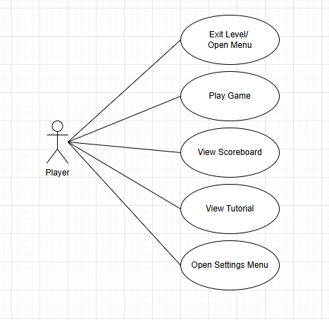

Scenarios
When playing, the user may either select tutorial or play. Scenario 1 will deal with play while scenario 2 will deal with the tutorial.

Scenario 1:
Playing a round of the game
The system assumes the player is familiar with whatever key bindings they have set up. The system will wait for the user to hit play. Once they have hit play, they will be presented with a selection of songs and a difficulty option. Once they have chosen both, the game screen will load, and a countdown begins. During the song, arrows will progress across the screen into an indicator of some sort that will let the user know when to hit buttons. The indicator will indicate when the user hits the button on time and shake when they miss the timing for the arrow. Each arrow will correspond with a button on the number pad.
If the user hits the wrong key and the key is not on the number pad, nothing happens. If the user hits a key on the number pad but not at the right time, their streak bonus is removed.
Music will be playing while the player hits the keys, arrows will be moving across the screen.
At the end of the level, the music stops and the player’s score is displayed on the screen.

Scenario 2:
The tutorial
If the user has never played before, they can select the scenario button for instruction on how to play. Once the tutorial is loaded up, the screen is darkened, and a section is highlighted while text appears explaining what that portion of the screen is used for and how to decipher it. The system then walks the user through pressing each button in sync with a single arrow that moves across the screen. Once they have properly pressed all the buttons, the tutorial plays a few seconds of a song for the user to practice. After they complete the few seconds of the song, the tutorial ends.
The player might hit the wrong key or hit it at the wrong time. When they do this, the tutorial resets to right before they hit the key so they can try again. It will continue to reset until they either quit or get it right.
The arrows will move across the screen and then be paused at specific times.

Scenario 3:

The score tally
As the user hits button in sync with the arrows, a score is calculated and added to the total score for the user. Each correct hit will have a base score for a correct hit. As well as partial scores for hits that are within a specified millisecond threshold.
30% | 60% | 100% | 60% | 30%

Each individual hit score is scaled by a streak multiplier. The scalar number goes up by 0.1 for every perfect hit and resets to 1.0 if the player misses a hit. The player can see their current “streak bonus” at the top of the screen next to their current score.
The user might hit the wrong key or at the wrong time. If they do, the game proceeds but their streak bonus is reset to 1.0.
The song will be playing, and arrows will be moving across the screen while the score is being tallied. At the end, the final score will be presented to the user and they will asked if they want to save their score to the leader board.

Domain Model

Simple Class Diagram
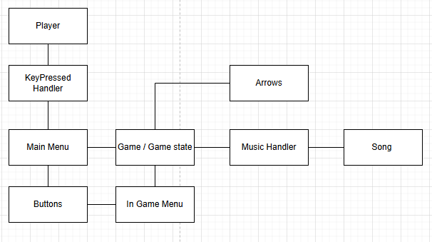

In-depth Class Diagram
The classes highlighted in red are items I am not sure how we will implement yet. They will exist but that is all we know so far.
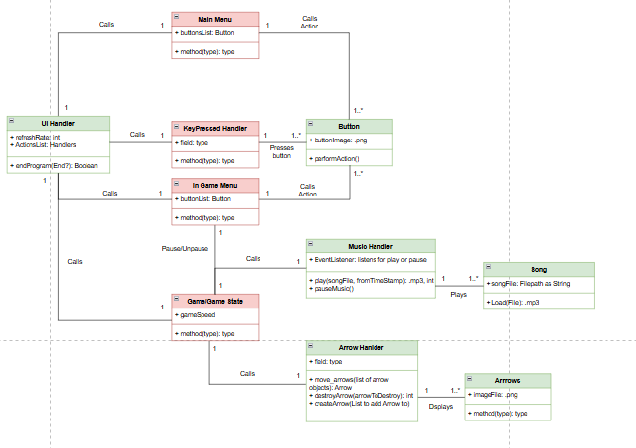
TODO: Add an event driven diagram for more in-depth analysis of scenarios
UI Sketches / Mockups
Four mockups of the main views the user will be presented.
